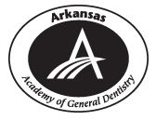 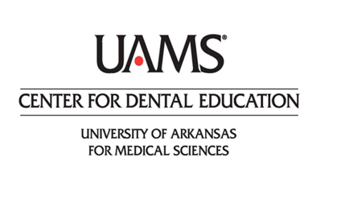

**Arkansas Academy for General Dentistry &**

**UAMS Center for Dental Education**

**present**

**TODAY’S TOP CLINICAL TIPS FOR SUCCESS**

**with Dr. Lee Ann Brady**

**Friday, April 26 & Saturday, April 27**

**8:00 am — 4:30 pm**

**UAMS NORTHWEST CAMPUS**

**FAYETTEVILLE**

**COURSE OVERVIEW**

Dentistry is changing at a rapid pace. Being successful and efficient is about staying on top of the newest trends and clinical tips. In this program, Dr. Brady will present the top clinical tips and techniques she is teaching. Some are old tried and true approaches that remain successful, while others introduce brand new materials and approaches. Tips will span the areas of prevention, posterior composites and indirect ceramics.

**FRIDAY**

**TODAY’S TOP CLINICAL TIPS**

* Caries and Perio Prevention
* Posterior Composite Efficiency and Effectiveness
* Successful Bonding & Cementation
* Improved Posterior All Ceramic Restorations
* Anterior Composite Layering Anterior Implant Esthetics
* Tissue Management & Impressions Provisionalization

**SATURDAY**

**BITE SPLINTS IN RESTORATIVE PRACTICE**

* TMJ and muscle evaluation and diagnosis
* Bite splint treatment protocols
* Increasing case acceptance during appliance therapy

**TREATMENT PLANNING & CASE PRESENTATION**

* Treatment Planning System
* Esthetic and Functional Exam & Diagnosis
* Creating a case presentation
* Interactive Treatment Planning

**Dr. Lee Ann Brady is a privately practicing dentist and nationally recognized educator, lecturer and author. With an extensive history in leadership, she is currently Director of Education of the Pankey Institute. Dr. Brady has also developed a vast library of online instruction at leeannbrady.com and restorativenation.com. She practices in Glendale, Arizona, is a member of the editorial board for the Journal of Cosmetic Dentistry, Inside Dentistry and Dentaltown Magazine.**

**COURSE DETAILS:**

Registration begins at 7:30am each day; sessions begin at 8:00am.

A light breakfast and box lunch will be provided both days.

**REGISTRATION:** [**https://www.eventbrite.com/e/todays-top-clinical-tips-for-success-with-dr-lee-ann-brady-tickets-56446412740**](https://www.eventbrite.com/e/todays-top-clinical-tips-for-success-with-dr-lee-ann-brady-tickets-56446412740)

**TICKETS:**

Both Days – AGD Member $575.00

Both Days – Non-Member $675.00

Both Days – Hygiene & Staff $175.00

One Day Only – AGD Member $299.00

One Day Only – Non-Member $375.00

One Day Only – Hygiene & Staff $99.00

AGD Mastertrack – both days $799.00

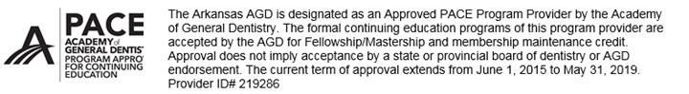

FOR MORE INFORMATION, CONTACT:

**Holly Johnson**

Education & GPR Residency Coordinator

CHP Center for Dental Education

Education Coordinator

COM Department of Pediatric & Special Care Dentistry

University of Arkansas for Medical Sciences

4301 W. Markham, Slot 624

Little Rock, Arkansas 72205

P: 501.686.8089

F: 501.686.6855